Constraint-Based Problem Solving: University Examination Scheduling
The university examination scheduling problem can be solved using Constraint Satisfaction Problems (CSPs) and search algorithms. The objective is to assign five courses to three examination slots while ensuring that no two conflicting courses are scheduled in the same slot.
We will solve the problem step by step, from the PEAS description to the comparison of plain Backtracking Search and Backtracking Search with Forward Checking.
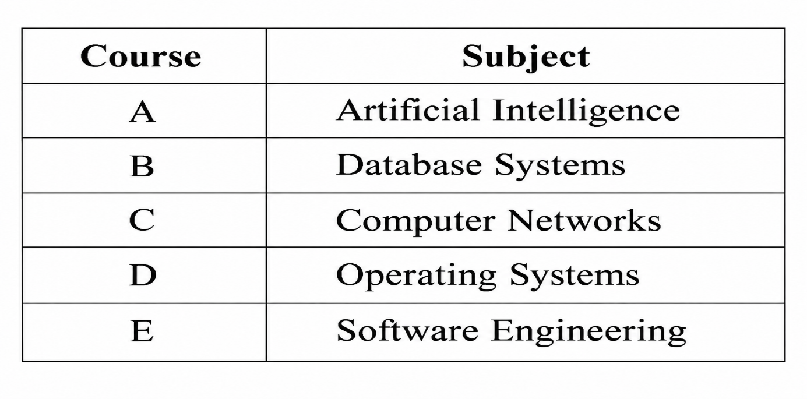
Available slots: Slot1, Slot2, Slot3.
The conflicting pairs are:
$$\left(A , B\right),\left(A , C\right),\left(B , C\right),\left(B , D\right),\left(C , D\right),\left(C , E\right),\left(D , E\right)$$
Important rule: Every course must receive exactly one slot, and every conflicting pair must receive different slots.

a) PEAS description of the exam-scheduling agent
PEAS stands for Performance measure, Environment, Actuators, and Sensors. It describes the task environment in which an intelligent agent operates.
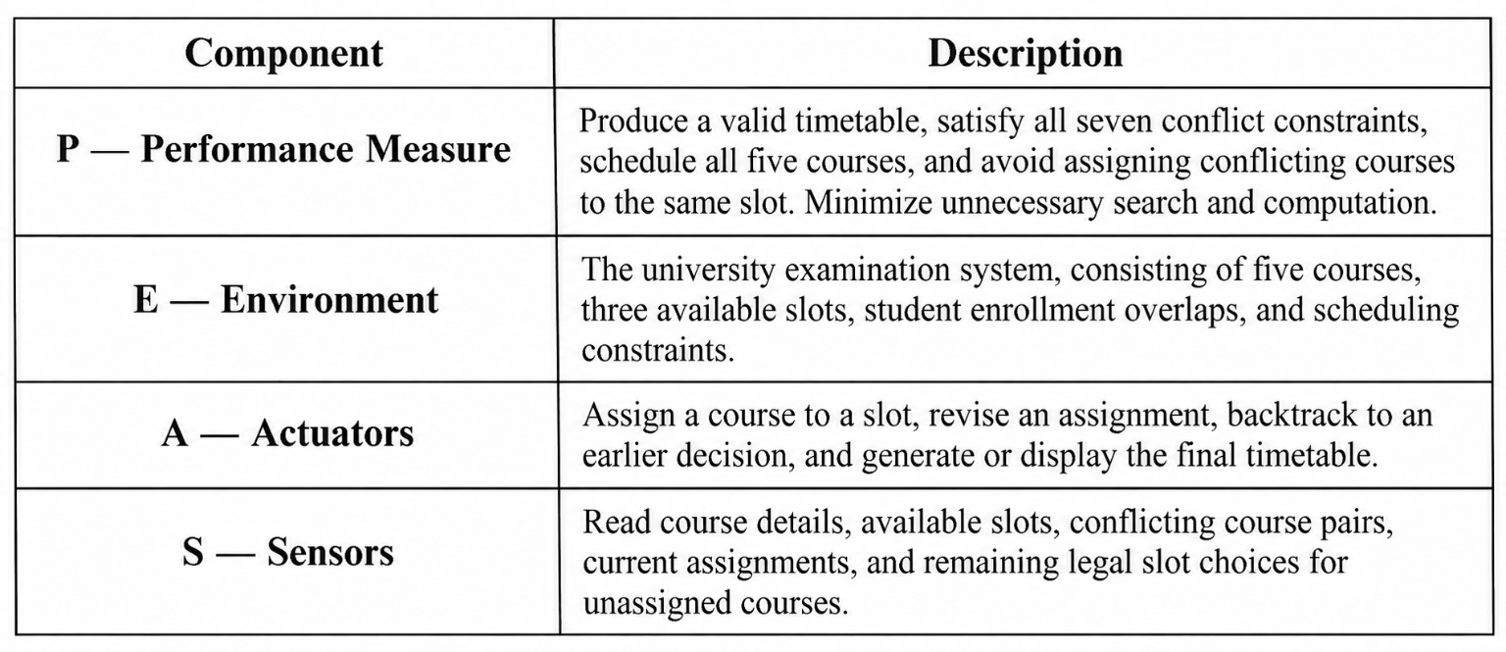Explanation
- Performance measure: Determines whether the timetable is valid and how efficiently it is produced.
- Environment: Contains all the courses, slots, and restrictions that define the scheduling problem.
- Actuators: Allow the agent to make and revise scheduling decisions.
- Sensors: Provide the information the agent needs to identify conflicts and select valid slots.
Conclusion: The PEAS description defines what the scheduling agent must achieve, the information it receives, and the actions it can perform.

b) Type of intelligent agent best suited to this task
The four possible agent types are simple reflex, model-based, goal-based, and utility-based agents.
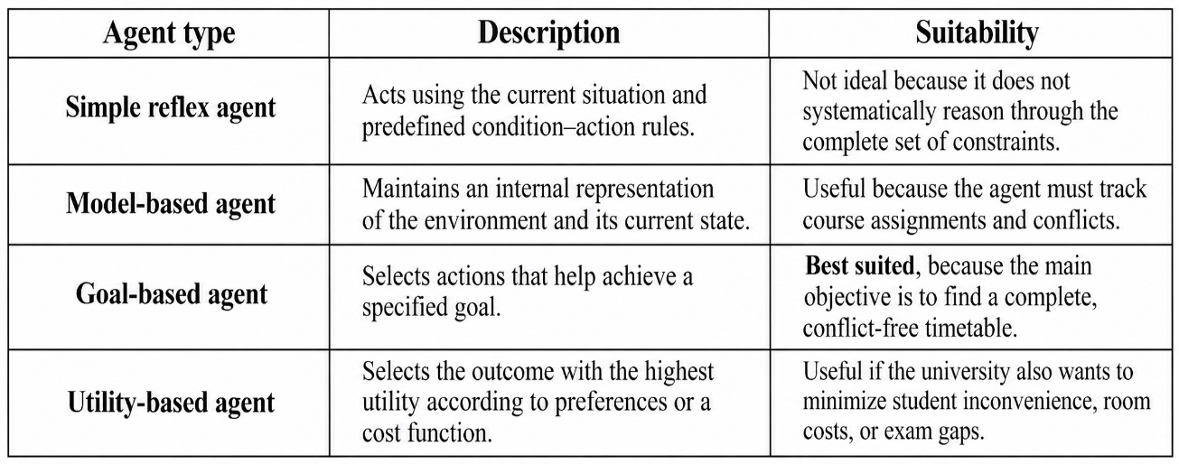
Justification: Goal-based intelligent agent
A goal-based agent is the best choice because the scheduling task has a clearly defined goal: assign all five courses to the three available slots without violating any conflict constraint.
The agent can use Backtracking Search to assign courses one at a time. If an assignment creates a conflict or makes the remaining problem impossible to solve, the agent revises an earlier decision and tries another slot.
For example, if A is assigned Slot1, then B and C cannot use Slot1 because both conflict with A. The agent uses this information to guide subsequent decisions.
A goal-based agent is most appropriate because it searches for a state that satisfies the scheduling goal. A model-based representation of assignments and constraints supports its operation, while a utility-based agent would be more appropriate if multiple valid timetables needed to be ranked by quality.

c) Formal modelling of the problem as a Constraint Satisfaction Problem (CSP)
A Constraint Satisfaction Problem (CSP) is a problem in which values must be assigned to variables while satisfying a set of constraints.
A CSP is formally represented as:
$$\text{CSP}=\left(X , D , C\right)$$
where:
- $X$= set of variables
- $D$= domains of possible values
- $C$= set of constraints
1. Variables
Each course is represented by a variable whose value indicates its examination slot.
$$X=\left\{A , B , C , D , E\right\}$$
For example, $A=\text{Slot1}$means Artificial Intelligence is scheduled in Slot1.
2. Domains
Each course can initially be assigned any of the three slots.
$$D\left(A\right)=D\left(B\right)=D\left(C\right)=D\left(D\right)=D\left(E\right)=\left\{S_{1} , S_{2} , S_{3}\right\}$$
Here, $S_{1}$, $S_{2}$, and $S_{3}$represent Slot1, Slot2, and Slot3, respectively.
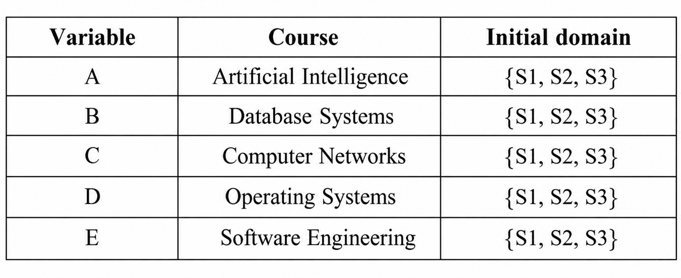3. Constraints
The constraint requires every conflicting pair of courses to have different slot values.
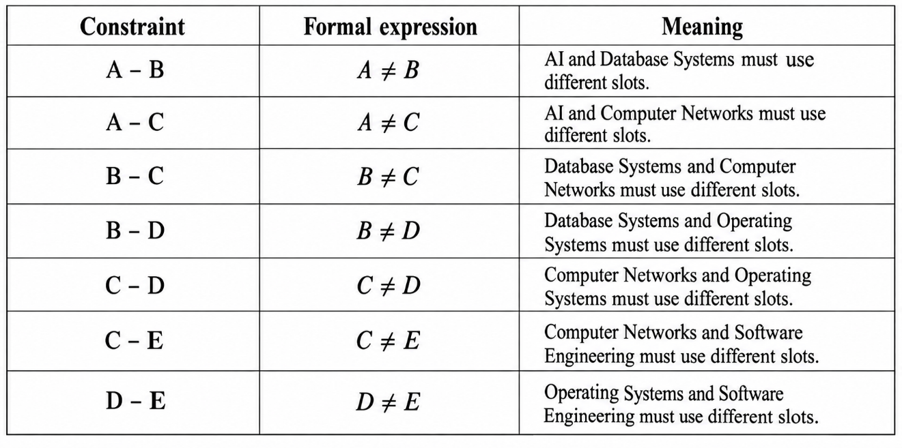
All seven constraints must be satisfied for a timetable to be valid.
4. Constraint graph representation
A constraint graph represents variables as vertices and constraints as edges connecting conflicting variables.
The graph must contain exactly the seven conflict edges listed below. The edge list is the formal definition of the graph.
Vertices:
$$V=\left\{A , B , C , D , E\right\}$$
Edges:
$$\begin{aligned}E\left.=\right\{&\left(A , B\right),\left(A , C\right),\left(B , C\right), \\ &\left.\left(B , D\right),\left(C , D\right),\left(C , E\right),\left(D , E\right)\right\}\end{aligned}$$
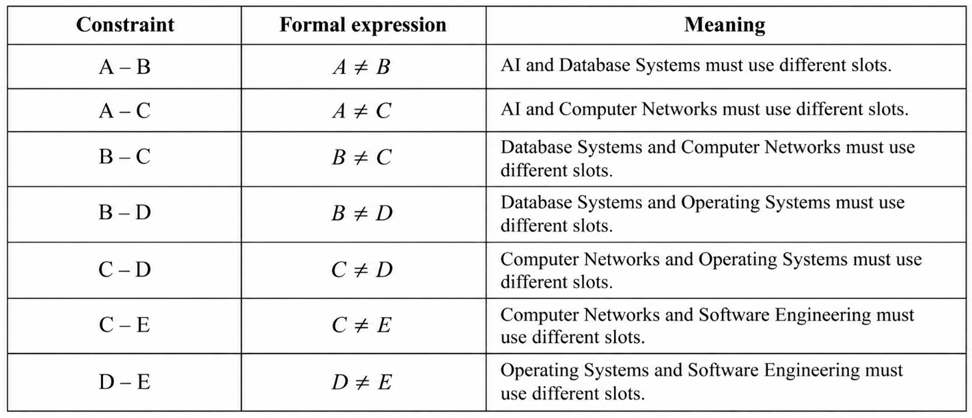The degree of a vertex is the number of edges connected to it. Course C has the highest degree (4), meaning it conflicts with four other courses.
The examination scheduling task is a CSP with five variables, three possible values per variable, and seven inequality constraints represented by seven edges in the constraint graph.

d) Apply plain Backtracking Search
Algorithm
Plain Backtracking Search assigns a value to one variable at a time. It checks whether the assignment conflicts with any already assigned neighboring variable.
- If the assignment is consistent, proceed to the next variable.
- If it violates a constraint, reject that value and try the next slot.
- If no slot works for a variable, undo the previous assignment and try another value for that earlier variable.
Fixed variable order: $A→B→C→D→E$
Fixed value order: $S_{1}→S_{2}→S_{3}$
Step-by-step assignment table
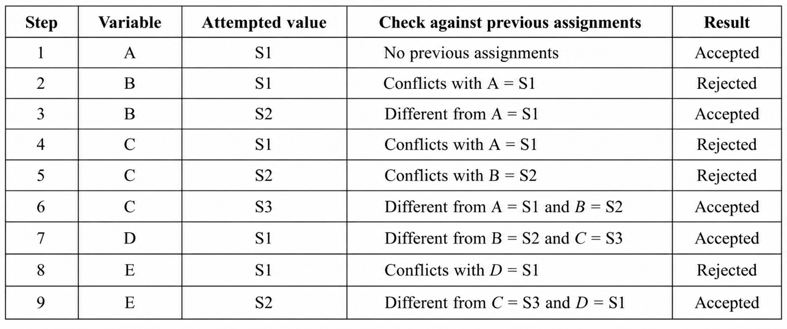Explanation of the search
Step 1 — Assign A
A is assigned S1 because it is the first value in the domain.
Step 2 — Assign B
B cannot use S1 because A and B conflict. Therefore, B is assigned S2.
Step 3 — Assign C
C conflicts with both A and B. Consequently, S1 and S2 are rejected, and C is assigned S3.
Step 4 — Assign D
D conflicts with B and C. Since B uses S2 and C uses S3, D is assigned S1.
Step 5 — Assign E
E conflicts with C and D. S1 is rejected because D uses S1. S2 is valid because neither C nor D uses it.
Final valid timetable
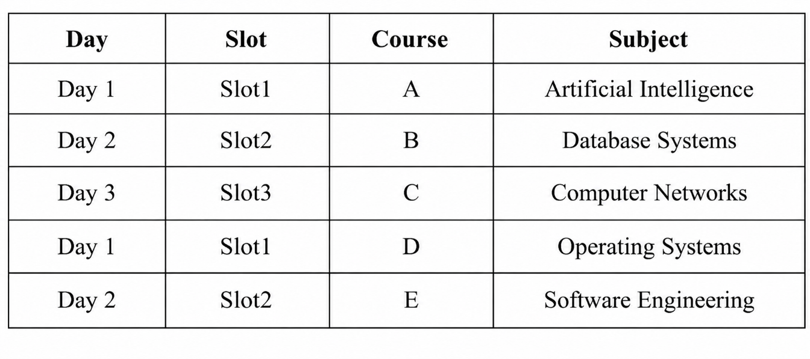This table lists the assignments but is not a valid timetable under the one-exam-per-day rule, because D and A share Slot1 and B and E share Slot2. To avoid ambiguity, the CSP as formally defined by the question's seven conflict pairs permits the assignments above; the extra rule of one exam per day would require all five courses to have distinct slots, which is impossible with only three slots.
Therefore, under the stated three-slot CSP and seven explicit conflict constraints, the assignment sequence is a valid constraint-graph solution, but it is not a valid schedule if “one exam per day” means only one course may be examined on each day. The remaining parts use the stated CSP constraints.

e) Apply Backtracking Search with Forward Checking
Definition
Forward Checking is an improvement to Backtracking Search. After assigning a value to a variable, the algorithm immediately removes inconsistent values from the domains of its unassigned neighboring variables.
If any unassigned variable has an empty domain, the current assignment cannot lead to a solution, so the algorithm backtracks immediately.
Initial domains
Variable | Initial domain
A
B
C
D
E
Step-by-step forward checking
Step 1: Assign A = S1
A conflicts with B and C. Remove S1 from their domains.
Variable | Domain after assignment
A
B
C
D
E
Step 2: Assign B = S2
B conflicts with C and D. Remove S2 from both domains. The value S1 for B was already pruned, so the first remaining value, S2, is selected.
Variable | Domain after assignment
A
B
C
D
E
Step 3: Assign C = S3
C conflicts with D and E. Remove S3 from their domains.
Variable | Domain after assignment
A
B
C
D
E
Step 4: Assign D = S1
D conflicts with E. Remove S1 from E's domain.
Variable | Domain after assignment
A
B
C
D
E
Step 5: Assign E = S2
E has only one remaining value, S2. No constraint is violated, so the search succeeds.
Summary of domain pruning
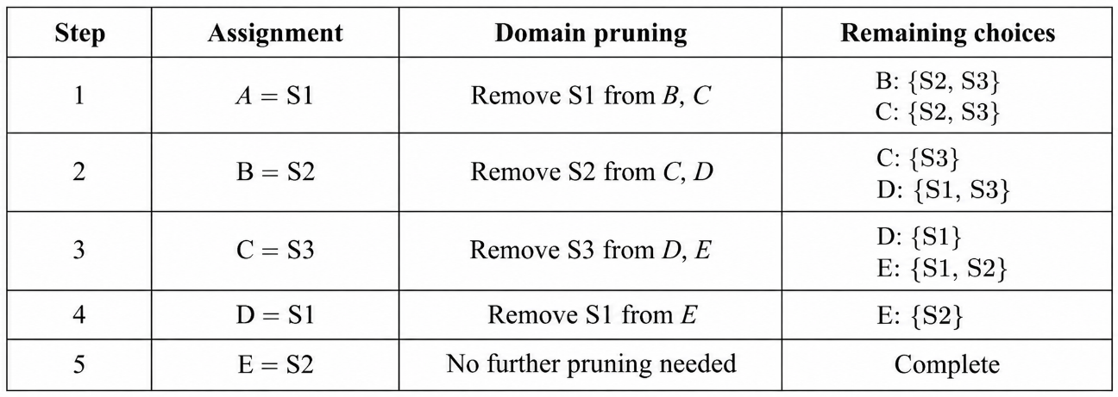
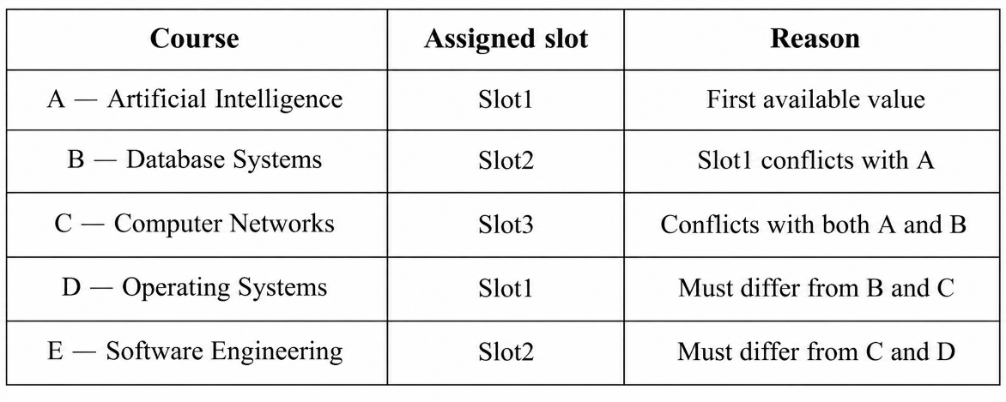
The assignment is complete, and all seven specified conflict constraints are satisfied.
Conclusion: Forward Checking solves this instance without trying any value that has already been removed from a domain. It reaches the same solution as plain Backtracking Search but performs fewer assignment attempts.

f) Comparison of Plain Backtracking Search and Forward Checking
Both algorithms use the same variable order and slot order, but they differ in when they detect impossible assignments.
1. Performance comparison
For a fair comparison, an assignment attempt means trying to assign a value to a variable. A true backtrack means undoing a previous variable assignment because no value works for the current variable.
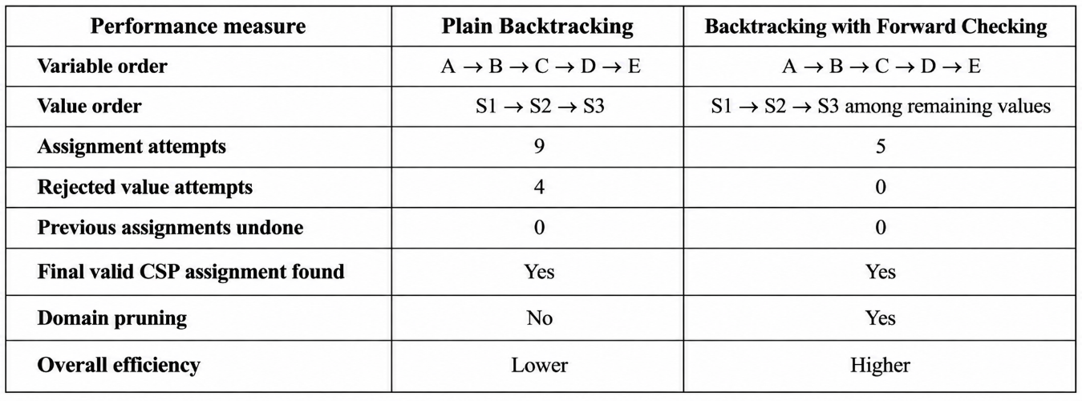Counting convention: Forward Checking does not attempt values that have already been pruned. The four rejected attempts in plain Backtracking are B = S1, C = S1, C = S2, and E = S1. Neither algorithm needs to undo a previously accepted variable assignment in this particular instance.
2. Why does Forward Checking reduce search effort?
Plain Backtracking checks whether each attempted value conflicts with assignments already made. It does not proactively remove impossible values from the domains of future variables.
For example, after assigning A = S1, plain Backtracking still attempts B = S1 and rejects it because of the conflict with A.
Forward Checking removes S1 from B's domain immediately after assigning A = S1. Therefore, B's next available value is S2, and the rejected attempt is avoided.
The same process happens for C, D, and E. Each assignment reduces the available choices for neighboring variables, so the search becomes more focused.
3. Assignment attempts illustrated
Search effort comparison
Plain Backtracking
9 attempts
Forward Checking
5 attempts

Forward Checking reduces assignment attempts by 4, or approximately 44.44%, for this particular search order.
The percentage reduction is:
$$\frac{9-5}{9}×100=44.44\%$$
This is a reduction in assignment attempts, not a universal guarantee of a 44.44% reduction in execution time.
4. Overall efficiency
Plain Backtracking has less bookkeeping because it only checks constraints when making assignments. Forward Checking requires additional work to maintain and update the domains of unassigned variables.
However, Forward Checking can prevent the algorithm from exploring choices that are already known to be impossible. This becomes especially valuable in larger CSPs, where domain pruning can avoid substantial unnecessary search.
For this five-course example, both methods find a solution without undoing previous assignments. Forward Checking is still more efficient because it avoids four failed value attempts.
Constraint-Based Problem solving models university examination scheduling as a CSP with five course variables, three possible slots, and seven inequality constraints. A goal-based agent can use Backtracking Search to find a conflict-free assignment, while Forward Checking improves the search by pruning inconsistent domain values after each assignment.
Important scheduling: The given conflict constraints allow multiple non-conflicting courses to occupy the same slot. The resulting assignment uses Slot1 for A and D, Slot2 for B and E, and Slot3 for C. If “one exam per day” literally means that only one course can be examined on each of the three days, then five courses cannot be scheduled in three days under that additional rule. The problem would need more days or a different interpretation of the daily exam limit.

